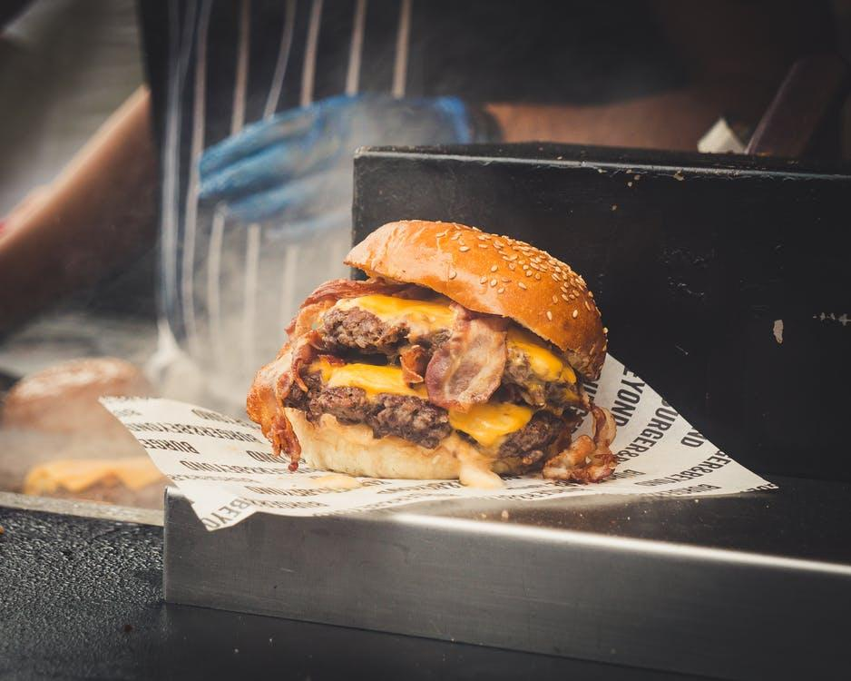Laacks Tavern Menu

Hamburger $4.25-$6.25 | Spicy Green Beans $4.25
Cheeseburger $4.75-$6.75 | Cheese Curds $4.50
Chopped steak $5.25-$7.25 | Curly Fries $2.50
B & B Burger $5.00-$7.00 | Egg Roll $2.00
Brat $3.50-$5.50 | Broccoli Cheddar Bacon Bites $4.50
Pork Chop $4.25-$6.25 | Empandas $2.75
Grilled Chicken $4.50 | Mushroom $3.75
Italian Herb Chicken $4.50 | Onion Rings $3.75
Peppery Boneless Wings $4:50 | Mac & Jack Bites $4.50
Cod Sandwhich $5.25 | Mini Corn Dogs $4.50
3 PC Cod & Fries $7.25 | Sidewinder Potatoes $3.50
Chicken Strips $4.00 | Potato Spuds $2.50
Rib Eye Sandwich $10.25 | Mini Taco $4.25
Shrimp $6.00
Shrimp, buy with a side save $1.50
Wings $6.25
Pizza $10:50

